

**Tribhuvan University**

**Faculties of Humanities and Social Sciences**

**BLOGGING SYSTEM**

**A PROJECT PROPOSAL**

**Submitted to**

**Department of Computer Application**

**Ratna Rajyalaxmi College**

**Exhibition Road, Kathmandu**

***In partial fulfillment of the requirements for the Bachelors in Computer Application***

**Submitted by**

Bisham Raj Pandey

Bishal Regmi

December, 2023

**TABLE OF FIGURES**

Figure 1: System Flowchart of Blogging System 7

Figure 2: Gantt Chart of Blogging System 8

**TABLE OF CONTENTS**

1. INTRODUCTION 1

2. PROBLEM STATEMENT 2

3.OBJECTIVES 3

4.METHODOLOGY 4

4.1. Requirement Identification 4

4.1.1. Study of Existing System 4

4.1.2. Requirement Collection 5

4.2. Feasibility Study 6

4.2.1. Technical 6

4.2.2. Operational 6

4.2.3. Economic 6

4.3. High Level System Design 7

4.3.1. System Flowchart 7

5.GANTT CHART 8

6.EXPECTED OUTCOME 9

7.REFERENCES 10

# 1. INTRODUCTION

A blogging system is a system where a user can blog about any topic they want. It allows a user to blog about their thoughts on any topic they want. Experts on many topics will get a platform to share their thoughts and views on their topics of interest and other people can read their blogs and gain useful information and insight on the topic.

The blogging system aims to redefine the user experience and address existing challenges in modern blogging platforms. This system will offer users a seamless and intuitive interface for creating, editing, and deleting blogs. One of the features includes a commenting system to foster engaging discussions on various blog posts. Each user will have their own personalized profile page, showcasing their blogs, comments, and interactions within the community as well as having a short bio section where they can redirect people to their previous works. Moreover, the system will introduce a direct messaging functionality, allowing users to communicate privately and build a sense of community among bloggers. Enhancing interaction, we plan to integrate a like and comment system for blogs, providing users with a means to express appreciation and feedback.

The main goal is to maintain a sense of community in an effective and accurate manner and providing useful information. This software helps to maintain blogs in day-to-day records in system. It is keeping a proper record of the database. I propose an online blogging system designed for use in any industry. This systems strength is its flexibility and adaptability.

# 2. PROBLEM STATEMENT

Modern blogging systems encounter various challenges that impact user experience and engagement. One prevalent issue is the complexity of content creation and editing interfaces, leading to user frustration and hindered creativity. Additionally, limited customization options often restrict bloggers from personalizing their pages to reflect their unique styles. The prevalence of spam comments and difficulties in moderating discussions pose challenges in maintaining a positive and constructive community. Some platforms struggle with optimizing for mobile devices, limiting accessibility for users on smartphones and tablets. Furthermore, the lack of seamless communication features, such as direct messaging between users, hampers community building. Overall, these challenges contribute to a less user-friendly and dynamic environment, hindering the potential for vibrant and interactive blogging communities.

Blogging systems are useful tools for people who want to learn or gain information about various topics and learn about unknown topics. The lack of communication between the blogger and the reader can cause the spread of misinformation and false data. This can hamper a learner's experience. The direct messaging system in the Blogging system will

Allow user to directly communicate with the blogger and check the validity of the statements. This will allow for moderation and control of false information. For this system, there will be a system administrator/moderator who will have the rights to delete any blogs with misleading or false information along with blogs which don’t follow the systems guidelines

# 3.OBJECTIVES

The main objective of this project is to develop an application which gives provision to the bloggers to blog and provide information at no cost and will invariably lead to higher literacy rates. The objective of this system is

* To develop a web-based responsive blogging system that provide blogging platform to the customers.
* To keep record of all the information of all blogs, bloggers, likes, and comments.
* To allow users and bloggers to chat/dm with each other.

# 4.METHODOLOGY

## 4.1. Requirement Identification

Secondary Sources of data collection was the primary method to gather requirements for the project. This has led to us finding useful requirements for the system.

### 4.1.1. Study of Existing System

The existing system refers to the system that is currently being followed by current blogging systems. Presently all blogging systems face problems with content creation. A blogger cannot stay motivated and create blogs daily [2]. A blogger can also be flooded by spam and hate comments by the commenters [1]. They can also, knowingly or unknowingly spread misinformation [3]. The main disadvantages of current system are the lack of inspiration required to create a blog, lack of moderation and lack of responsive pages for other devices.

**Problems of Existing System**

* While making blogs, a blogger needs to go through various pages and UI interfaces to upload a blog
* There is lack of responsiveness in the systems
* It is hard for the system to check and filter spam comments.
* The process of receiving feedbacks and comments on blogs is time consuming
* The record keeping system is poor which might cause loss of vital records
* It is difficult to moderate content on the systems.

**Advantages of Proposed System**

To overcome the restrictions of the above system, Blogging System is proposed which has the following advantages:

* People can successfully blog using the proposed system.
* The blogger cam creates and edit blogs easily.
* The system will help in spreading knowledge and educating people on various topics
* All the records of the blogs, comments and likes will be stored in the database.
* The moderators will help to make clean, safe and correct content

### 4.1.2. Requirement Collection

To commence the development of the envisioned system, an initial phase of requirement analysis was undertaken, drawing insights from existing systems. Manual studies were done to gather essential data for a total understanding of the project. The subsequent step involved the actual implementation of the system, with us collectively selecting a theme for the application based on ideas. The implementation of the system was started. In the final stage, the system was finished. The start of the project was marked by setting a defined goal, prompting the initiation of the requirement collection process. Various methods were employed for requirement collection.:

* Literary Analysis

Through a comprehensive review and critical analysis of existing literature, the project identified past works, pinpointing their strengths and weaknesses. This process informed the project's aims and objectives by revealing the shortcomings of prior solutions. The literature review played a crucial role in refining the project's direction, guiding it toward addressing issues gleaned from past research.

* Observation

Multiple blogging websites were visited and studied to identify current trends in blogging application development. Simultaneously, a review of typical blogging systems was conducted to gain insights into blogging process. This analysis aims to inform a comprehensive understanding of blogging platforms, shaping a well-informed approach to web application development

* Brainstorming

Brainstorming was employed as a creative tool for idea generation. The requirements for the system were partially derived from this brainstorming process, capturing a range of ideas and insights.

## 4.2. Feasibility Study

The analysis of feasibility has concluded that the project is feasible with respect to time and cost. The technology used to develop are almost Open Source, therefore less cost for implementation and maintenance will be involved.

### 4.2.1. Technical

The implementation of the system is adaptable to a range of current technologies and is designed to integrate with any future technologies that may be introduced.

* Hardware Requirement

Processor: 800MHz Intel Pentium III or equivalent or new

Disk space: 50MB or more

RAM: 128MB or more

* Software Requirement

Operating System: Windows (7 or more)

Web Browser: IE 10 or above, Mozilla FF and above or Google Chrome

XAMPP, MySQL

* Language used: Hypertext Markup Language (HTML), Cascading Style Sheets (CSS), Hypertext Preprocessor (PHP), Structured Query Language (SQL), JavaScript (JS)

### 4.2.2. Operational

Operational feasibility pertains to the effectiveness with which the system addresses issues and capitalizes on opportunities as outlined during the system's scope definition. The project is deemed to be feasible to operate.

* The current mode of operation provides good throughput and response time.
* The organization will gain significant benefits from the proposed system.
* The resources available are used to the maximum capacity to deliver quality system on time.

### 4.2.3. Economic

This seeks to assess the positive economic advantages that the proposed system will offer to the organization.

* The system is cost effective
* The efficient management of rehouses will diminish the cost of this system
* The benefits of this system will outweigh the costs.

## 4.3. High Level System Design

### 4.3.1. System Flowchart

The system flowchart of Blogging system is shown as follows:

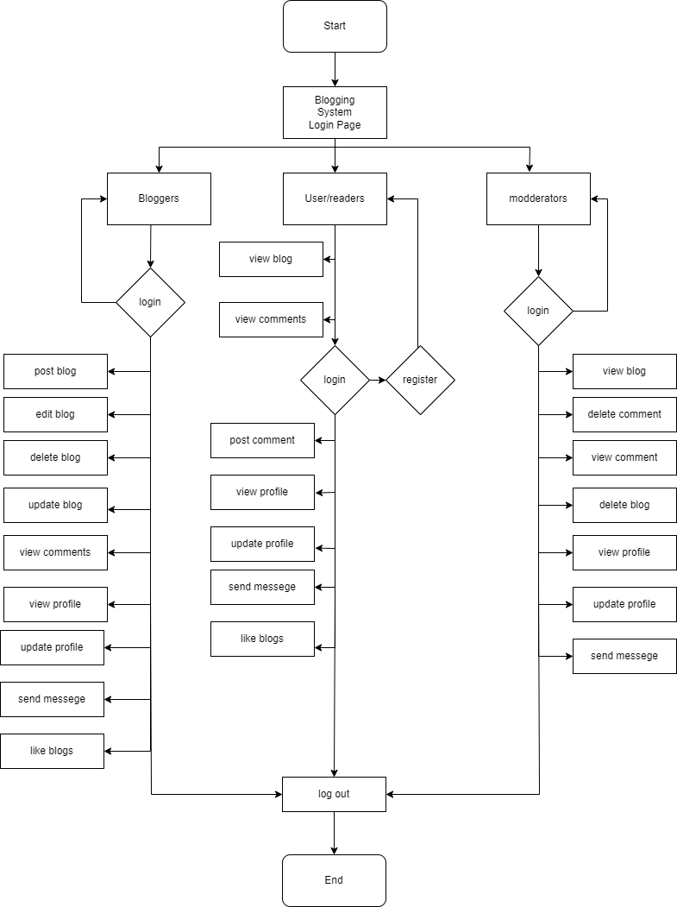

# Figure 1: System Flowchart of Blogging System

# 5.GANTT CHART

# Figure 2: Gantt Chart of Blogging System

We plan to initiate our project starting from the second week of Paush 2080. The planning phase will extend until the end of Paush. Concurrently, the analysis phase will commence. As this phase nears completion, our focus will shift to data modeling, where we will gain clarity on entities, attributes, key attributes, cardinality, and the overall process of our system. Following data modeling, we will delve into process modeling by creating Data Flow Diagrams (DFDs) and their respective levels. Subsequently, we will transition into the design phase during the last week of the Magh month, initiating the design of the Graphical User Interface (GUI) in the final week of Paush. In the latter part of the design phase, we will establish the database for our system.

Directly after the design phase, we will embark on coding the system from the first week of the Magh month. This phase is anticipated to take about a month to reach completion. Testing activities will commence in the middle of the Magh month, continuing even after the system is fully coded. Thus, testing will persist until the first week of the Falgun month. Recognizing the significance of documentation in our system, we will commence documentation from the project's inception, i.e., the second week of Paush. However, the preparation of comprehensive documentation will only occur after the final testing phase of our system concludes.

# 6.EXPECTED OUTCOME

After the completion of the project, we expect the subsequent outputs which can minimize the issues likewise as solve the prevailing problem.

* Enhanced Blogger Convenience: Bloggers can easily upload blogs on various topics of interest without much hassle.
* Responsive System: The site will be responsive and work as intended on different devices.
* Feedback and Reviews: Viewers and bloggers can communicate easily with different systems like direct messaging and comments.

|  |  |
| --- | --- |
| [1] | ijdhas, "facebook," 12 april 2005. [Online]. Available: esaasdasd. [Accessed 1 january 2024]. |
| [2] | S. Anderson, "mashable.com," 29 August 2019. [Online]. Available: https://mashable.com/article/best-tumblr-scams. [Accessed 22 12 2023]. |
| [3] | J. Parson, "Content Powered," 3 November 2023. [Online]. Available: https://www.contentpowered.com/blog/reasons-blog-isnt-working/. [Accessed 25 December 2023]. |
| [4] | N. Agarwal, "researchgate.com," 1 November 2017. [Online]. Available: https://www.researchgate.net/publication/329658800_BLOGS_FAKE_NEWS_AND_INFORMATION_ACTIVITIES. [Accessed 26 December 2023]. |

# 7.REFERENCES